

**QGIS Lab Series**

**GST 102: Spatial Analysis**

**Lab 6: Vector Data Analysis - Network Analysis**

**Objective – Learn the Basics of Network Analysis**

**Document Version:** **2014-07-17 (Final)**

**Author:**

Kurt Menke, GISP



**Contents**

1 Introduction 2

2 Objective: Learn the Basics of Network Analysis 2

3 How Best to Use Video Walk Through with this Lab 2

Task 1 Basic Network Analysis 2

Task 2 Allocating Service Areas 9

5 Conclusion 20

6 Discussion Questions 21

7 Challenge Assignment 21

1. Introduction

In this lab, you will learn how to conduct analyses related to linear networks. You will learn how to determine the shortest path from origin to destination and how to allocate a linear network into service areas.

This lab includes the following tasks:

Task 1 Basic Network Analysis

Task 2 Allocating Service Areas

1. Objective: Learn the Basics of Network Analysis

The objective of this lab is for the student to learn how to conduct basic network analysis. You will use the Road Graph plugin to QGIS Desktop, and you will be introduced to the GRASS plugin. You will use some of the networking tools in GRASS to allocate service areas.

1. How Best to Use Video Walk Through with this Lab

To aid in your completion of this lab, each lab task has an associated video that demonstrates how to complete the task. The intent of these videos is to help you move forward if you become stuck on a step in a task, or you wish to visually see every step required to complete the tasks.

We recommend that you do not watch the videos before you attempt the tasks. The reasoning for this is that while you are learning the software and searching for buttons, menus, etc…, you will better remember where these items are and, perhaps, discover other features along the way. With that being said, please use the videos in the way that will best facilitate your learning and successful completion of this lab.

1. Basic Network Analysis

In this task, you will use the **Road Graph** plugin to determine the shortest distance between two points via a San Francisco streets layer. You will do this both by shortest overall distance and by time traveled.

1. The data for this lab is located on the lab machine at: *C:\GST102\Lab 6\Data.*
2. **Open QGIS Desktop 2.4.0**
3. **Add** the **MTA_DPT_SpeedLimits** shapefile to **QGIS Desktop.**
4. **Right click** on the layer and choose **Set project CRS from layer** from the context menu**.**

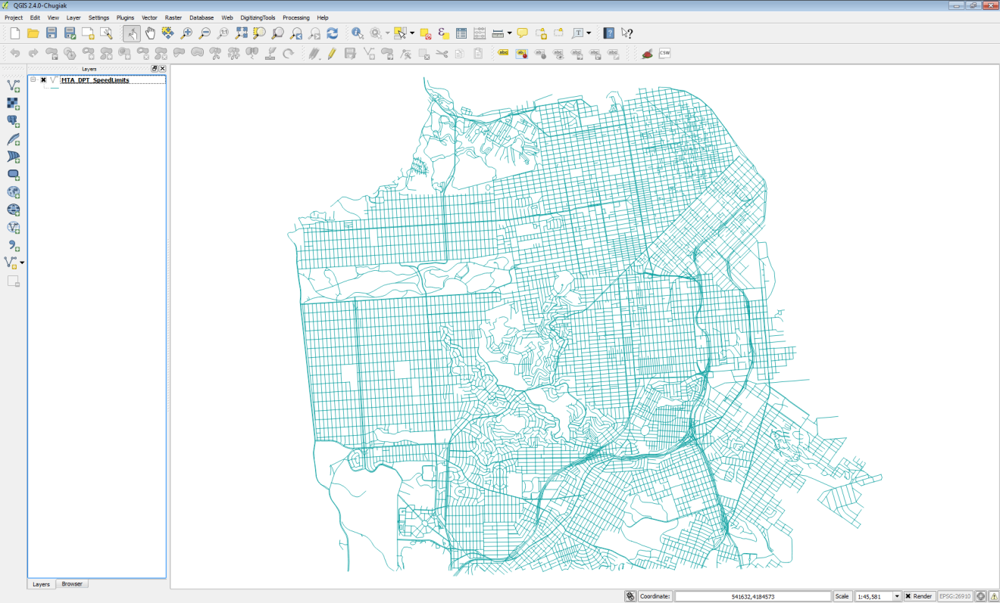

**Figure 1: Street Layer in QGIS Desktop**

1. This is a street network for the City of San Francisco. **Open** the **attribute table** to see what kind of data you have to work with. Notice that in addition having the street name and type, there is a column populated with speed limits for each road segment. **Close** the **attribute table**.
2. Open the **Layer Properties🡪 Style** and symbolize the data by speed limit.
   1. Choose a **Categorized** renderer
   2. **Column** = ***speedlimit***
   3. Color ramp = **Greys**
   4. **Click** **Classify**
   5. **Click OK (Figure 2)**

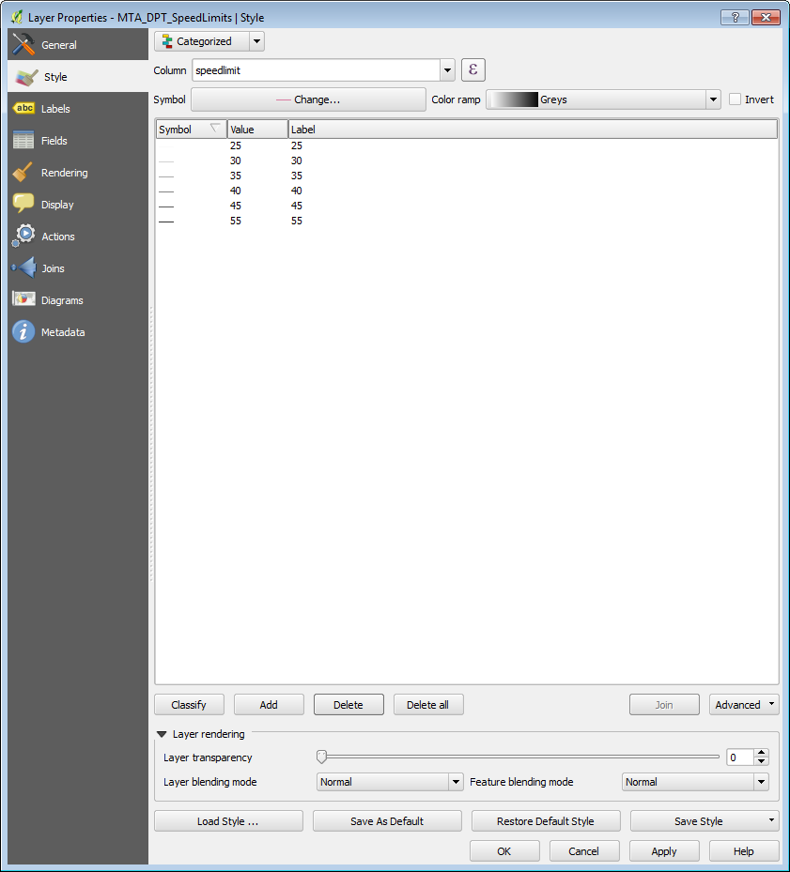

**Figure 2: Styling the Street Layer by Speed Limit**

1. Your map should resemble **Figure 3**.You can now distinguish the major arteries.

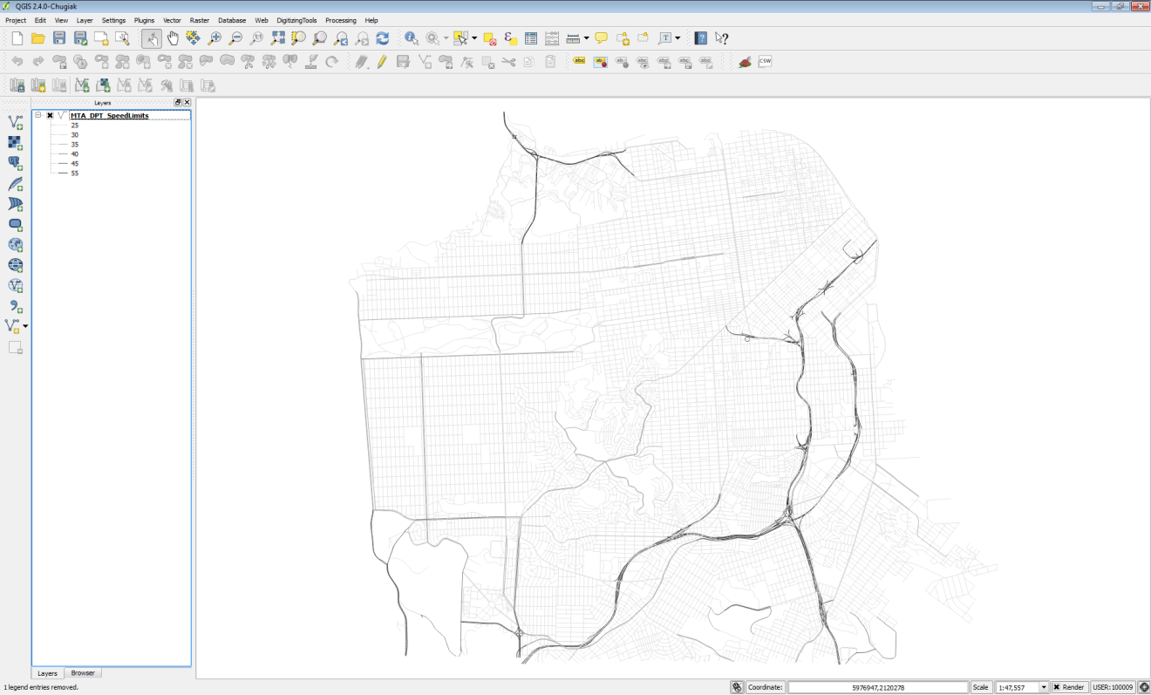

**Figure 3: San Francisco Streets Styled by Speed Limit**

1. **Save** your map as **Lab 6.qgs**.
2. You will use the QGIS **Road Graph** plugin to find the shortest distance between two points on the network. From the menu bar choose **Plugins 🡪 Manage and Install Plugins.** **Select** the **All** tab, and type **Road** into the **Search bar**. Check the box next the **Road graph plugin** to enable it (**Figure 4**). **Click Close.**

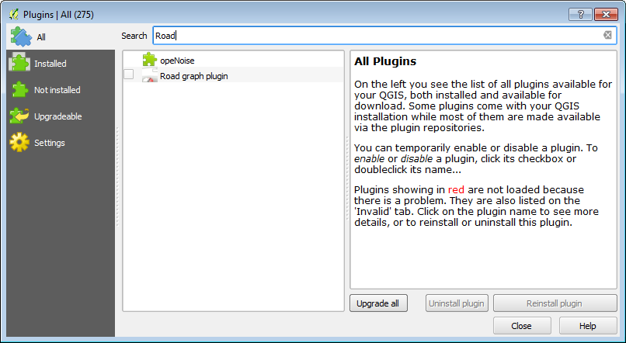

**Figure 4: Enabling the Road Graph Plugin**

1. A new panel for this plugin will appear below the Table of Contents.
2. Before you begin you need to configure the plugin. From the menu bar, choose **Vector 🡪 Road Graph🡪 Settings**. The **Road Graph settings** window opens. Choose the following settings (**Figure 5**):
   1. Time unit: **hour**
   2. Distance unit: **kilometer**
   3. Topology tolerance: **10**
   4. Layer: **MTA_DPT_SpeedLimits**
   5. Direction field: **Always use default**
   6. Speed field: **speedlimit**
   7. **Click OK.**

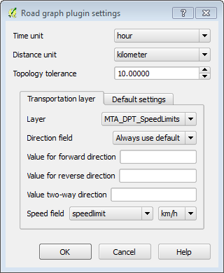

**Figure 5: Enabling the Road Graph Plugin**

1. Now you will populate the **Road Graph** plugin panel (below the Table of Contents). **Click** the **Start** **location**  button and **click** on a spot on the map. Do the same for the **Stop location** via the **Stop location** button. Small dots will appear where you have clicked.
2. **Set** the **Criterion** as **Length**. Now **click Calculate** to find the shortest path between the two points. After some processing, a red line will appear as the solution (**Figure 6**).

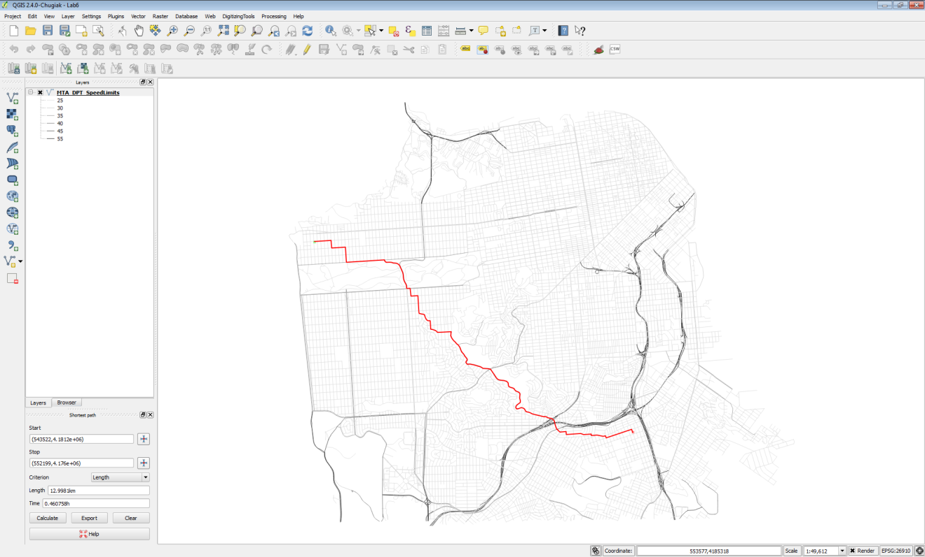

**Figure 6: Shortest Path Between Two Points on Linear Network**

1. To save the shortest path click the **Export** button. Choose **New temporary layer** as the **Select destination layer**. **Click OK**. The shortest path will now appear in your Table of Contents.
2. To make this layer permanent **right click** on it and choose **Save as**… Save the data to a shapefile in the Lab 6/Data folder named **ShortestPath.shp** (**Figure 7**).

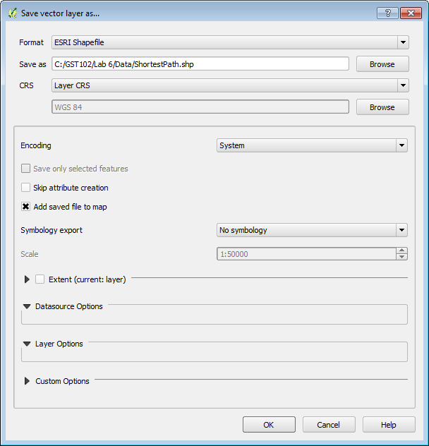

**Figure 7: Saving the Temporary Shortest Path Layer to a Shapefile**

1. Now you will determine the shortest drive time between the two points. Change the **Criterion** to **Time**. **Click Calculate**. With this Criterion, you may get a very different solution, depending on the points you chose.
2. **Click Export** to save this layer to a **New temporary layer,** and again, save that temporary out to a shapefile. **Name** this file **FastestRoute.shp**
3. **Remove** the temporary layers from the map, leaving just the street network and two solutions. **Style** the **ShortestPath** layer as a red line with a **thickness** of **0.46** and the **FastestRoute** layer with a **dark blue** line of equal thickness. With the points I chose, I had two very different solutions (**Figure 8**).

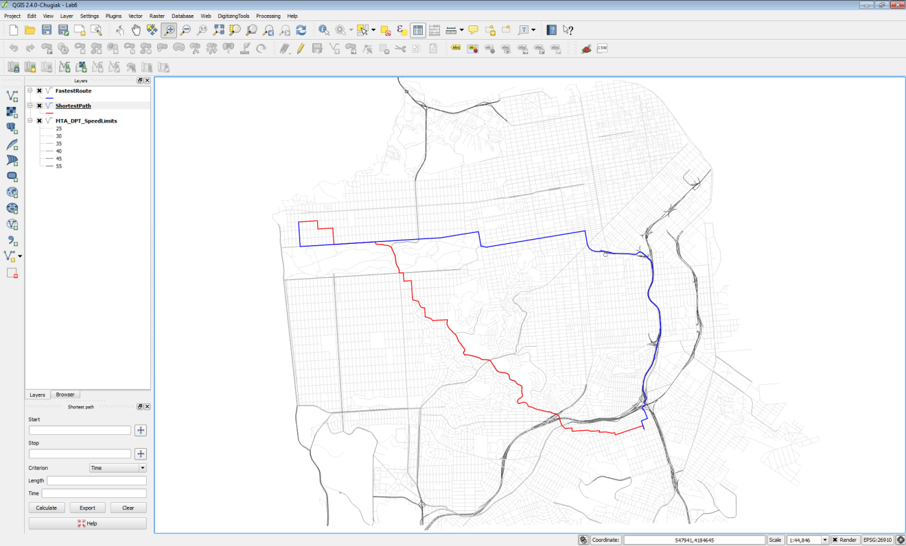

**Figure 8: Final Solutions**

1. **Save** your map file and close **QGIS Desktop**.
2. Allocating Service Areas

Now you will use some GRASS tools to allocate portions of the road network served by each San Francisco Police Station. GRASS is a mature and powerful FOSS GIS software package. It has a unique data structure that can be initially intimidating. Fortunately, QGIS Desktop has a GRASS plugin that provides a much more intuitive interface to the large suite of GRASS analysis tools.

1. **Open QGIS Desktop 2.4.0** and open Lab 6/Data/**Lab6_Task2.qgs**
2. This project has three layers loaded: **SF_Police**, **SF_FireStations** and **SF_Streets**.

GRASS uses its own file format. These layers are stored in a GRASS Database, which is essentially a folder with containing GRASS data. The Grass Database is **Lab 6/Data/GRASSdb**. These data sets have been imported into GRASS from shapefiles. In QGIS Desktop they will behave just like any other layer. However, since they are stored as GRASS Vectors, you can also use the suite of GRASS tools with them. These tools include a set for network analysis.

1. First, you will enable the GRASS plugin. From the menu bar choose **Plugins 🡪 Manage and Install plugins**. The GRASS plugin is a core QGIS plugin. This means it is already installed and all you need to do is enable it. **Click** on the **Installed** tab. Find **GRASS** and **check** the box to turn it on. **Click Close** when done.
2. Enabling GRASS turns on a new toolbar (below).



The data is already set up for you in this QGIS Desktop project. The following is simply an explanation to get you oriented to the GRASS data structure. Remember GRASS data is stored in a **GRASS database**, which again is simply a folder. Inside the database will be folder(s) called **Locations** and inside a **Location** will be folder(s) called **Mapsets**.

**GRASSdb 🡪 Locations🡪Mapsets**

**Locations** represent a certain spatial extent and coordinate reference system that you identify when you create one. **Mapsets** are a way to organize data and are the data tier that actually contains data layers. Every Location contains a default **Mapset** named **PERMANENT**. Additional **Mapsets** can be set up for individual users (Tom, Mary, Alice etc,) or for categories of data such as hydrology, transportation, boundaries etc.

To begin working with the GRASS tools you need to have a GRASS **Mapset** open.

This QGIS project has three data layers from a **GRASS Database** however, you need to open a **Mapset** to begin working with GRASS tools. Additionally, the **Mapset** you have open determines where your outputs will be saved. For this lab there is an empty **Mapset** called **MyData** that you will open to complete Task 2.

1. From the GRASS toolbar, **click** on the **Open Mapset**  button. Fill out the **Select GRASS Mapset** window as in **Figure 9**.
   1. The Gisdbase should be: **Lab 6\Data\GRASSdb**
   2. Location: **Lab6_SanFrancisco**
   3. Mapset: **MyData**

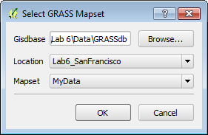

**Figure 9: Select GRASS Mapset**

1. There will be two changes that occur. 1) You will see a red box appear around your data on the map. This represents the **Region** of study (**Figure 10**), which in this case is equal to the **Location** settings. It is the spatial extent of your study area. 2) The remainder of the buttons on the GRASS toolbar are now active.

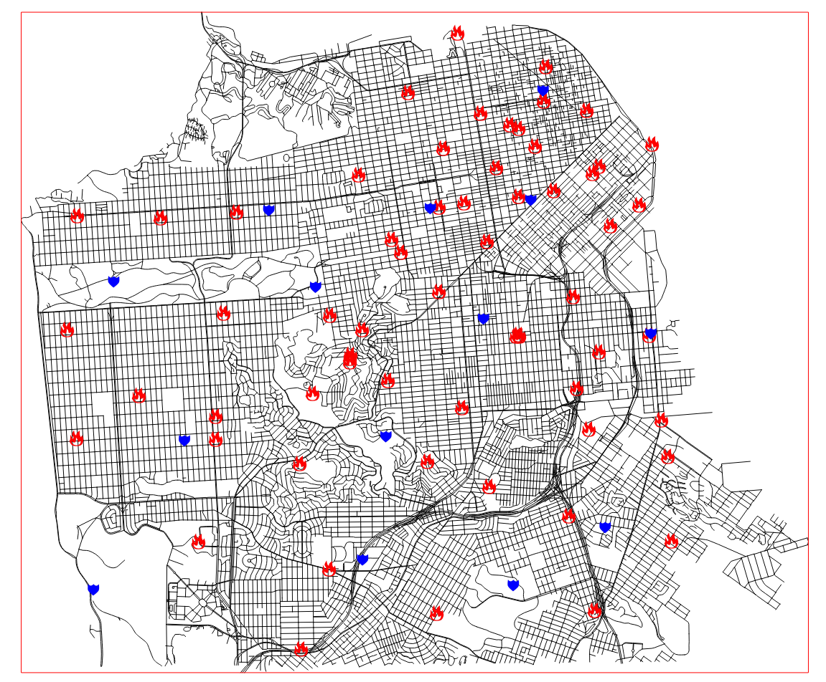

**Figure 10: GRASS Mapset Open**

1. **Click** the **Open GRASS Tools**  button.
2. The **GRASS Tools** window opens. This is the interface to all the GRASS geoprocessing tools. Notice that in the title bar of the window it displays your Location/Mapset (**Lab6_SanFrancisco/MyData**) (**Figure 11**)

The GRASS Tools window has three tabs: Modules Tree, Modules List and Browser. The **Modules Tree** allows you to access GRASS tools organized by theme. The Modules **List** has all the same tools, but they are listed alphabetically with a search bar. The **Browser** allows you to see what layers you have in your open **Mapset**. You do not yet have data in your **MyData** **Mapset** so there will be nothing yet to see.

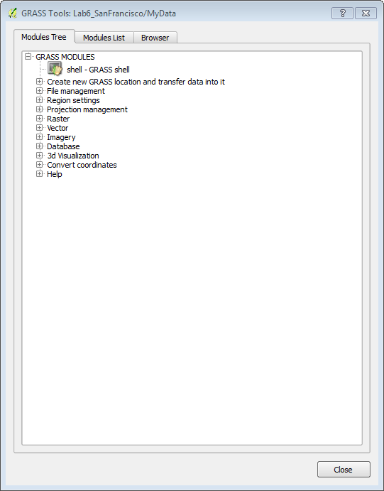

**Figure 11: GRASS Tools**

1. The first step in doing a network analysis in GRASS is the build a network dataset. **Expand** **Vector🡪Spatial Analysis 🡪 Network analysis🡪 v.net** (**Figure 12**). This tool will create a linear network of San Francisco streets and attach nodes representing the Police stations.

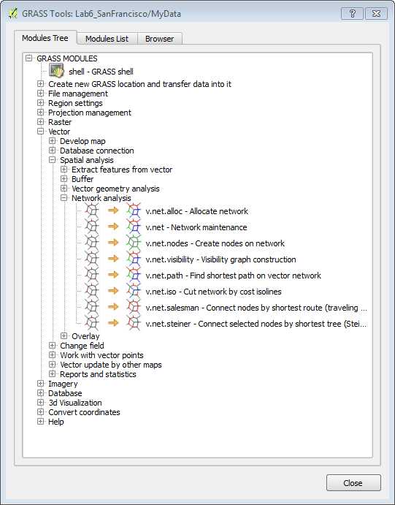

**Figure 12: GRASS Network Analysis Tools**

1. **Double click** on the **v.net – Network Maintenance** tool. The tool opens as an addition tab on the window to the right of **Browser**. Additionally, the tool itself has three tabs. Options, Output and Manual. The **Options** tab is where you fill out your parameters before running the tool. When you run the tool, it will switch to the **Output** tab and you will see details about the running process. The **Manual** tab is help for the tool. Fill it out as described below and in **Figure 13**.

NOTE: The inputs are listed as LayerName@Mapset.

* 1. Name of input vector map: **SF_Streets (SF_Streets@PERMANENT 1 line)**
  2. Name of input point vector map: **SF_Police ( SF_Police@PERMANENT 1 point)**
  3. Operation to be performed: **Connect still unconnected points to vector network by inserting new line(s)**
  4. Arc layer: **1**
  5. Node layer: **2**
  6. Threshold: **300**
  7. Name for output vector map: **SF_Network**
  8. **Click Run**

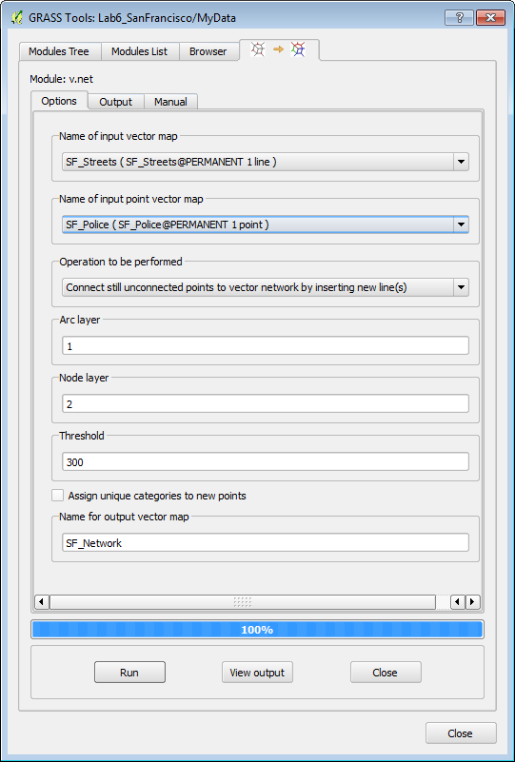

**Figure 13: v.net Tool**

1. While running the **Output** tab will be visible (**Figure 14**). **Click** the **View output** button to add the network dataset to QGIS.

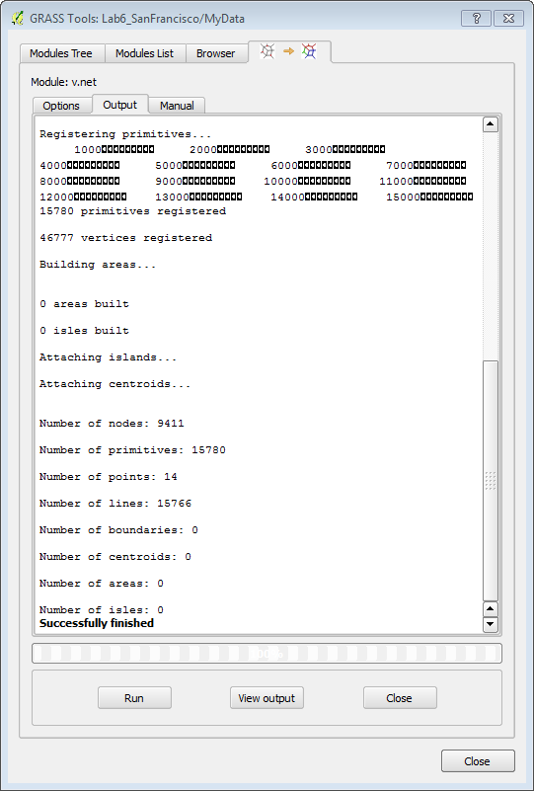

**Figure 14: v.net Tool Successfully Finished**

1. For now, **leave the GRASS tools window open.** You may want to move it to the side so you can see the map.
2. **Turn** **off** the **SF_FireStations** and **SF_Police** layers.
3. In addition to the linear network, this operation produced nodes for each police station point. The **View output** only added the linear network to QGIS, so you will now add the network nodes to QGIS. On the **GRASS toolbar click the Add GRASS Vector Layer**  button.
4. The **Select GRASS Vector Layer** window opens. Under Mapset: MyData, Map name SF_Network **choose 2_point** (**Figure 15**). *Remember when you ran the v.net tool you specified that the ID for the Arc layer was 1 and the node layer 2.*

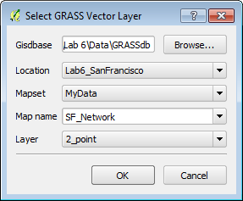

**Figure 15: Select GRASS Vector Layer**

1. **Open** the **attribute table** for the **SF_Network_2 node** layer**.** It has one column named **cat** with values for each of the 14 police stations **(1-14). Close the table.**
2. Now that the network dataset is constructed, you will identify the road territory that each police station should serve. In the **GRASS Tools** window switch back the **Modules Tree** tab. **Click** on **v.net.alloc – Allocate Network** tool. The tool will open in yet another tab.
3. Fill out the tool form as described below and as seen in **Figure 16**.
   1. Input arcs: **SF_Network ( SF_Network@MyData 1 line)**
   2. Input nodes: **SF_Network 2 ( SF_Network@MyData 2 point)**
   3. Cats: **1,2,3,4,5,6,7,8,9,10,11,12,13,14** *NOTE: these are the values for each police station from the SF_Network_2 node attribute table.*
   4. Name for output vector map: **PoliceSt_Allocation**

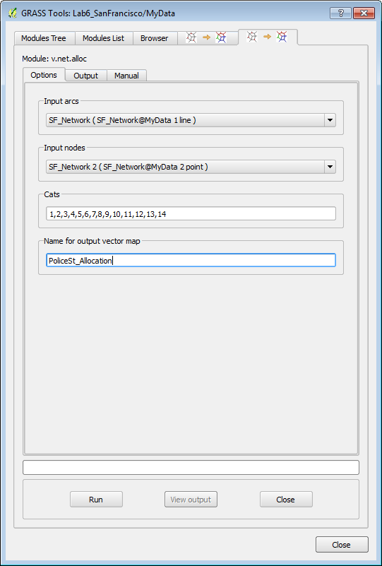

**Figure 16: v.net.alloc Tool**

1. When the tool is set up correctly, **click Run**. When complete click **View output**.
2. **Open** the **attribute table** for the **PoliceSt_Allocation** layer**.** Notice that it simply has the cat ID of each of the 14 police stations.
3. Before you close the GRASS Tools window **switch** to the **Browser tab. Click** the **Refresh ** button**. Expand MyData🡪Vector** and **PERMANENT🡪Vector.** You will see the data layers listed in each **Mapset** (**Figure 17**).

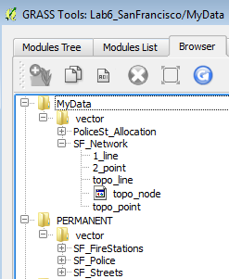

**Figure 17: GRASS Tools Browser**

1. **Now click** on the **SF_Network** layer and you will see some metadata in the right hand window (**Figure 18**). This is the command line equivalent of the tool parameters you used. This can be helpful when trying to remember how you created a given layer.

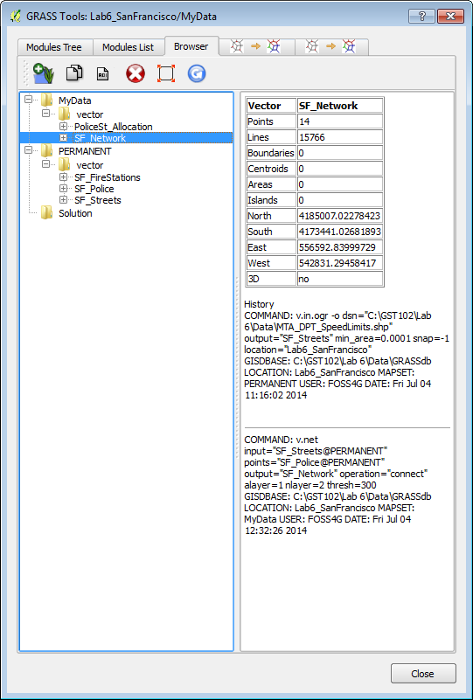

**Figure 18: GRASS Tools Browser Displaying Metadata**

1. **Close** the **GRASS Tools** window.
2. To see the results of your analysis you will **Style** the **PoliceSt_Allocation** layer. **Open** the **Layer Properties 🡪 Style** tab. Choose the following parameters:
   1. Renderer: **Categorized**
   2. Column: **cat**
   3. Color ramp: **Random colors**
   4. **Click** **Classify**
   5. **Click OK**
3. Now **turn OFF** the **SF_Network 2** layer and **turn ON** the **SF_Police** layer.
4. Next you will label the Police stations with their name. **Open** the **Layer Properties🡪Labels** tab for the **SF_Police** layer.
   1. Check the **Label with layer with** box
   2. Choose **FACILITY_N** as the attribute column
   3. **Click** the **Text tab** below and make the font size **9** and **Bold**
   4. **Click** the **Buffer tab** and click **Draw text buffer** and make the size **2**
   5. **Click OK.**
5. Your map should resemble **Figure 19**.

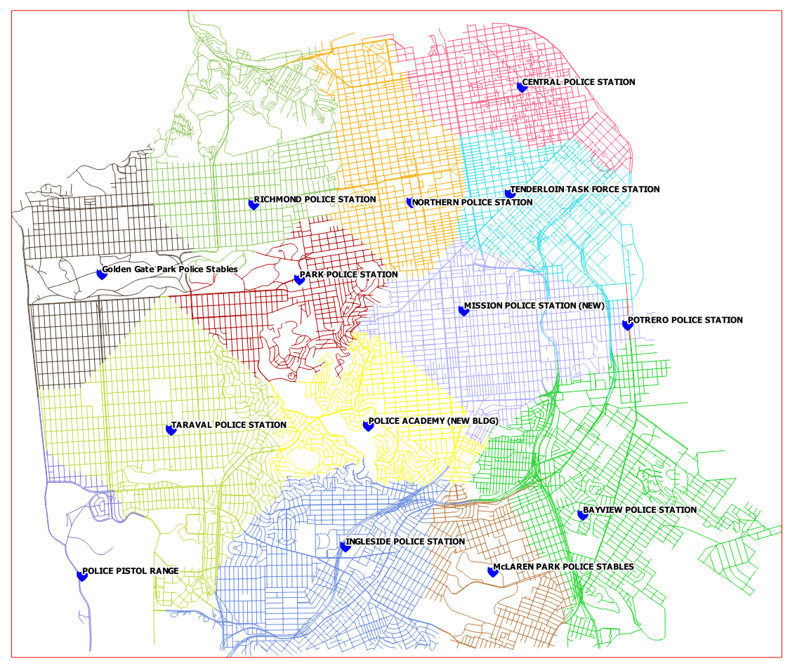

**Figure 19: Road Allocation by Police Station**

5 Conclusion

In this lab, you were exposed to basic network routing and allocation analysis. You calculated the shortest distance between two points via both time and distance. You then determined which portions of the network that should be allocated to each police station. There are many applications for this type of analysis including emergency management, parcel delivery, and general navigation.

6 Discussion Questions

1. What is a real world application of network analysis? Explain.
2. How can a network analysis benefit the logistics industry?
3. What other linear networks could this apply to other than roads?

7 Challenge Assignment

The San Francisco Police Department has shown your analysis to their colleagues at the Fire Department and they were impressed. Now the Fire Department would like the same analysis done for their stations. In the PERMANENT mapset there is a SF_FireStations GRASS vector layer. Repeat the steps in Task 2 to create the same allocation analysis for the Fire Department. Compose a map of the results of the Fire Department analysis.